Trial by ordeal
Trial by ordeal is a judicial practice by which the guilt or innocence of the accused is determined by subjecting him to an unpleasant, usually dangerous experience. Classically, the test is one of life or death and the proof of innocence is survival. In some cases, the accused is considered innocent if he escapes injury or if his injuries heal.

Ordeal of fire or similar
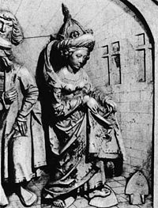
Ordeal of fire typically required that the accused walk a certain distance, usually nine feet, over red-hot ploughshares or holding a red-hot iron. Innocence was sometimes established by a complete lack of injury, but it was more common for the wound to be bandaged and re-examined three days later by a priest, who would pronounce that God had intervened to heal it, or that it was merely festering in which case the suspect would be exiled or executed. Another form of the ordeal required that an accused remove a stone from a pot of boiling water, oil, or lead. The assessment of the injury and the consequences of a miracle or lack of one, followed a similar procedure to that described above. An early (non-judicial) example of the test was described by Gregory of Tours in the 7th century. He describes how a Catholic saint, Hyacinth, bested an Arian rival by plucking a stone from a boiling cauldron. Gregory accepted that it took Hyacinth about an hour to complete the task (because the waters were bubbling so ferociously), but he was pleased to record that when the heretic tried, he had the skin boiled off up to his elbow.

Ordeal of boiling water
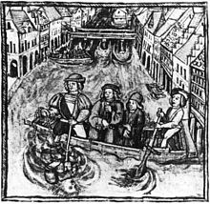
King Athelstan made a law concerning the ordeal. The water had to be about boiling, and the depth from which the stone had to be retrieved was up to the wrist for one accusation and up to the elbow for three. The ordeal would take place in the church, with several in attendance, purified and praying God to reveal the truth. Afterwards, the hand was bound and examined after three days to see whether it was healing or festering.
This was still a practice of 12th century Catholic churches: the priest would demand a suspect to place his hand in the boiling water. If after three days, God had not healed his wounds, the suspect was guilty of the crime.

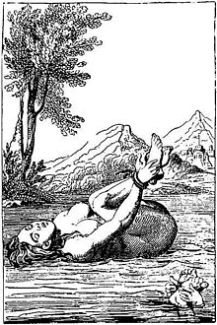
Ordeal of cold water
The ordeal of cold water has a precedent in the Code of Ur-Nammu and the Code of Hammurabi, under which a man accused of sorcery was to be submerged in a stream and acquitted if he survived. The practice was also set out in Frankish law but was abolished by Louis the Pious in 829. The practice reappeared in the Late Middle Ages: in the Dreieicher Wildbann of 1338, a man accused of poaching was to be submerged in a barrel three times and to be considered guilty if he sank to the bottom.

Ordeal of the cross
The ordeal of the cross was apparently introduced in the Early Middle Ages by the church in an attempt to discourage judicial duels among the Germanic peoples. As with judicial duels, and unlike most other ordeals, the accuser had to undergo the ordeal together with the accused. They stood on either side of a cross and stretched out their hands horizontally. The one to first lower his arms lost. This ordeal was prescribed by Charlemagne in 779 and again in 806. A capitulary of Louis the Pious in 819 and a decree of Lothar I, recorded in 876, abolished the ordeal so as to avoid the mockery of Christ.

Ordeal of ingestion
Franconian law prescribed that an accused was to be given dry bread and cheese blessed by a priest. If he choked on the food, he was considered guilty. This was transformed into the ordeal of the Eucharist (trial by sacrament) mentioned by Regino of Prüm ca. 900: the accused was to take the Eucharist after a solemn oath professing his innocence. It was believed that if the oath had been false, the criminal would die within the same year.

Ordeal of boiling oil
Trial by boiling oil has been practiced in villages in India and in certain parts of West Africa, such as Togo. There are two main alternatives of this trial. In one version, the accused parties are ordered to retrieve an item from a container of boiling oil, with those who refuse the task being found guilty. In the other version of the trial, both the accused and the accuser have to retrieve an item from boiling oil, with the person or persons whose hand remains unscathed being declared innocent.

